**AUTOMATION OF MEDICAL RECORD MANAGEMENT SYSTEM**

**CSC320**

**SOFTWARE LABORATORY**

**SUBMITTED TO:**

**THE DEPARTMENT OF COMPUTER SCIENCE**



**FEDERAL UNIVERSITY OYE EKITI**

**BY**

**BAYODE BLESSING AKINBOLA**

**CSC/2017/1072**

**UNDER THE GUIDANCE OF:**

**Dr. Adewole.**

**JULY, 2021.**

Table of Content

1. Introduction. ………………………. 2
2. Statement of the problem. ………………………. 2
3. Methodology. ………………………. 3
4. Algorithm. ………………………. 4
5. Implementation. ………………………. 7
6. Users’ Guide. ………………………. 13
7. References. ………………………. 14
8. **Introduction**

Health is wealth as it is commonly said. It is no longer a news that the mental or psychological behaviour of humans depends on the state of humans’ physical and medical well-being. World Health Organization (WHO) bad really played a very big and essential role in the global governance of health by establishing, monitoring and enforcing international norms and standards to coordinate multiple actors towards common goals. (Jennifer et al.).

However, technology is taking over in every areas of human activities especially the cognitive and convoluted aspects of human life purposely to achieve the same goal with human or better-off.

The most common way of keeping Medical Records for decades had been manual (paper record). (Mandl, 2001). However, the promise of a more efficient hospital service is obvious using Electronic Medical Records Management Systems (Stroetmann et al., 2011).

From personal experience in many Nigerian hospitals (Federal University Oye Ekiti (FOUYE) Medical Centre inclusive), it was observed that medical records are managed manually which had led to many difficulties in record management such as inconsistency or duplicate in records as well as loss of time during collations and distribution of medical files to different departments within the hospital.

More to the merits of Electronic Medical Record Management System is the safety of record during environmental and natural disaster occurrence such as fire outbreak, water spillage or criminal attacks.

1. **Statements Of The Problem**

Consequent to manual medium of keeping medical records is the inauspicious stress undergone by the Medical Record Officer during the registration of new Patients (Opening of new Medical Records), transferring or allocation of Patients’ medical file(s) within the departments and in the case of office/store or cabinet relocation is alarming. Likewise the complexity in time Management during record sorting, searching and retrieving is nothing to reckon with.

More so, the risk of data loss, file damages, duplicate in patient medical records and lack of privacy is high in traditional ways of managing records.

**2.1. Aims And Objectives**

The aim is to develop an Automated System for managing Medical Records using Federal University Oye (FUOYE) Medical Center as Focus Group.

**Objectives:**

1. To carry out a feasibility study for the development of FUOYE Medical Record Management System.
2. To design and develop a System for FUOYE Medical Centre.
3. To test and validate the Automated System.
4. To implement and evaluate the Medical Record Management System.
5. **Methodology**

**3.1.** The methodology subsequent to the development of the system are as follows:

**3.1.1.** Collection and understanding data.

**3.1.2.** Identifying the relationships between data sets.

**3.1.3.** Design of the database.

**3.1.4.** Design of the System Graphical User Interface (GUI) with Java programing language using JSWING and AWT.

**3.1.5.** Writing of Stored Procedures.

**3.1.6.** Development of the communication links between the application and the database.

**3.2. Hardware**

This Automated System was developed using a Personal Computer (PC) with 8G RAM, 500G Hard drive and core i5 Processor.

**3.3 Software**

The Software used for the development of this System are:

1. Windows 10 Pro. as the Personal Computer’s Operating System.
2. Eclipse For Developers, Standard Edition IDE.
3. JDK 13 as Java Compiler.
4. MySQL Workbench.

**3.4. Data Acquisition**

A Literature Research was conducted to gather relevant data for the development of the System.

During data collection process, the Matron and other Medical Personnel were interviewed to confirm, update, and understand the relationships between data collected.

1. **Algorithm**

STEP 1: Start.

STEP 2: Patient detail verification.

STEP 3: Is Patient verified?

NO: Displays “Invalid Credential” and go to STEP 2.

YES: Continue.

STEP 4: Patient joins the queue.

STEP 5: Is Patient picked up?

NO: Remain on queue.

YES: Continue.

STEP 6: Patient consulting the Doctor.

STEP 7: Does Patient need test?

YES: STEP 8: Patient visits the Laboratory.

STEP 9: Go to STEP 4.

NO: Continue.

STEP 10: Does Patient need drug?

NO: Go to STEP 13.

YES: Continue.

STEP 11: Dispense drug.

STEP 12: Stop.

**4.2. Flowchart**

**NO**

**NO**

**YES**

**NO**

**YES**

**YES**

**Laboratory**

**Needs test?**

**Start**

**Consultation with the Doctor**

**Patient picked?**

**Patient joins the queue**

**Is details valid?**

**Patient Verification**

**YES**

**NO**

**Stop**

**Stop**

**Dispends drug**

**Needs drug?**

**Pharmacy**

1. **Implementation**

**5.1. Architecture**

Authorization

**fuoye_medic**

Database

**5.2. Functional Requirements**

1. Registration of new Patient(s).
2. Easy search of Patient’s Medical Record especially during emergency.
3. Shows how often a Patient visit the Hospital.
4. Shows the Doctor that frequently attends to a particular Patient.
5. Monitoring of Patient’s Medical Process within the Hospital.
6. Remote access to the database server.

**5.3. Non-functional Requirements**

1. Medical Record confidentiality.
2. Access control function.

**5.4. Input Design**

According to the data collected, the formats for input data are as follows:

**5.4.1. Doctor**

1. Medication – String
2. Administration – String

**5.4.2. Laboratory Attendant**

i. Fasting Blood Sugar – Integer

ii. Random Blood Sugar – Integer

1. Sugar level – Integer
2. Malarial parasite – String
3. Typhoid test – String
4. Pregnancy test – String

**5.4.3. Pharmacist**

Comment (Reason for rejection) – String

**5.4.4. Medical Record Officer**

i. Names – String

ii. Age – Integer

iii. Date – YY-MM-DD

iv. Address – String

v. Image – Portable Network Graphic (.png)

**5.5. Database Design**

1. authorized_users (user_id, surname, first_name, post, password, username).
2. course (course_id, patient_id, faculty, department, entry_year, entry_level).
3. history (id, patient_id, pregnancy, sugar_level, typhoid, fbs, rbs, malarial_parasite, temperature, bp, weight, status, medication, regection_reason, doctors_comment, lab_test, date, process, doctorName)
4. initial_test (id, patient_id, pregnancy, sugar_level, typhoid, fbs, rbs, malarial_parasite, temperature, bp, weight, breast_test, xray, eyes_test)
5. next_of_kin (nok_id, patient_id, surname, first_name, address, phone_number)
6. parents (parent_id, patient_id, surname, firstname, address, phone_number)
7. patients (patient_id, surname, firstname, midde_name, sex, dob, weight, height, blood_group, genotype, address, temperature, phone_number)

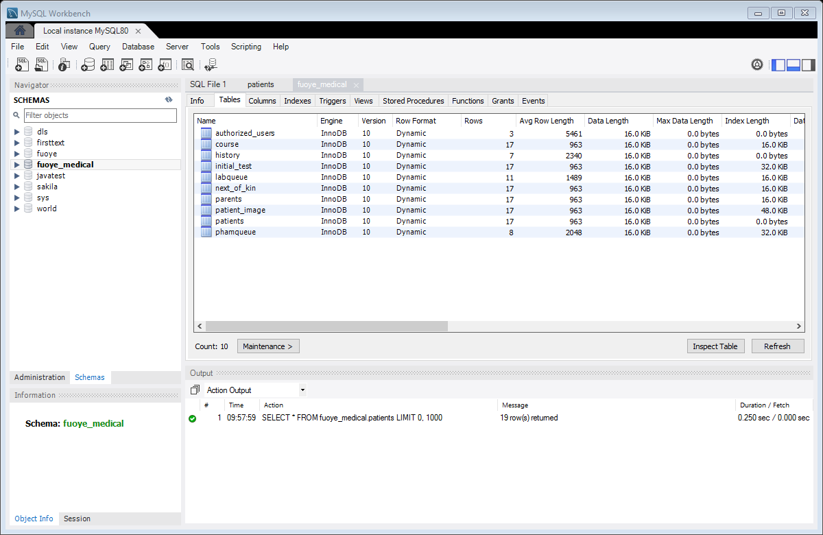

**5.6. Interface Design**

**Login**

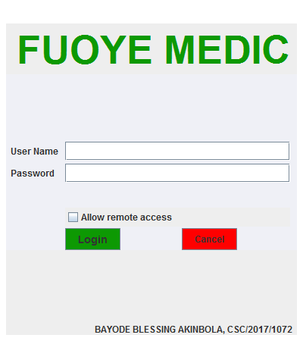

**Doctor**

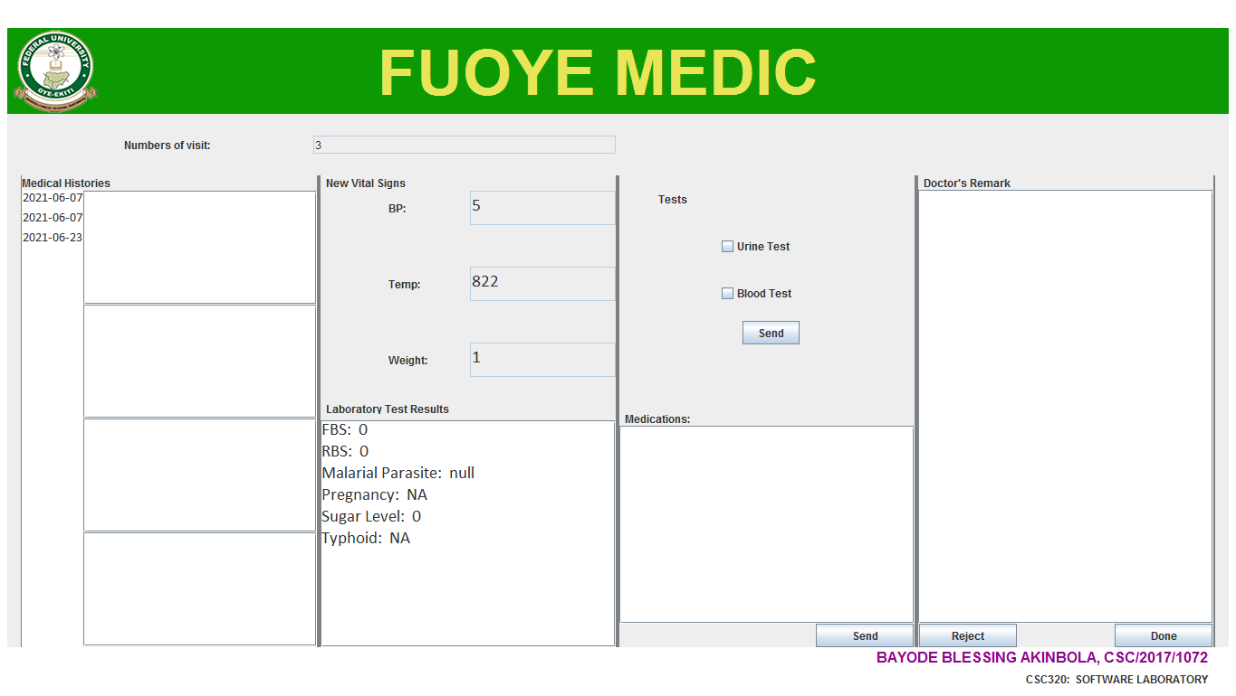

**Laboratory**

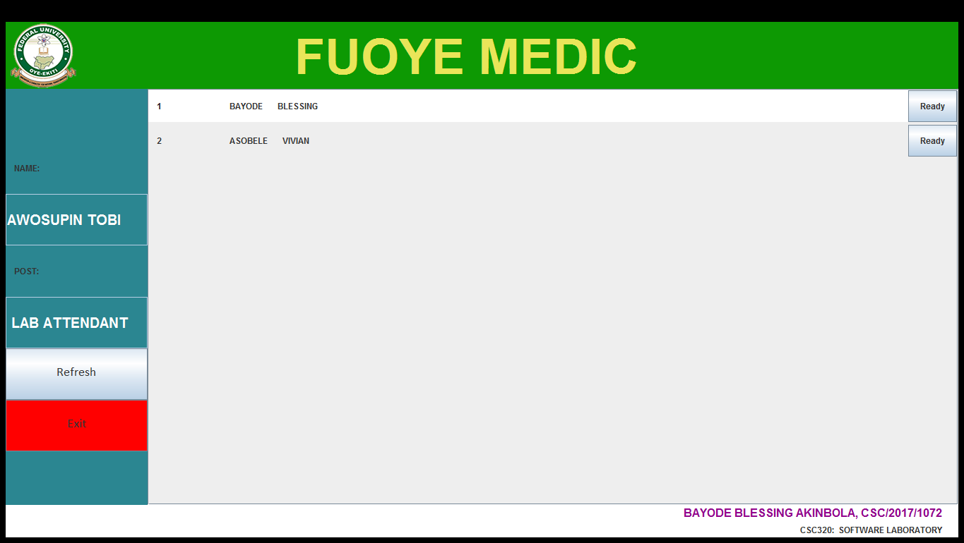

**Pharmacy**

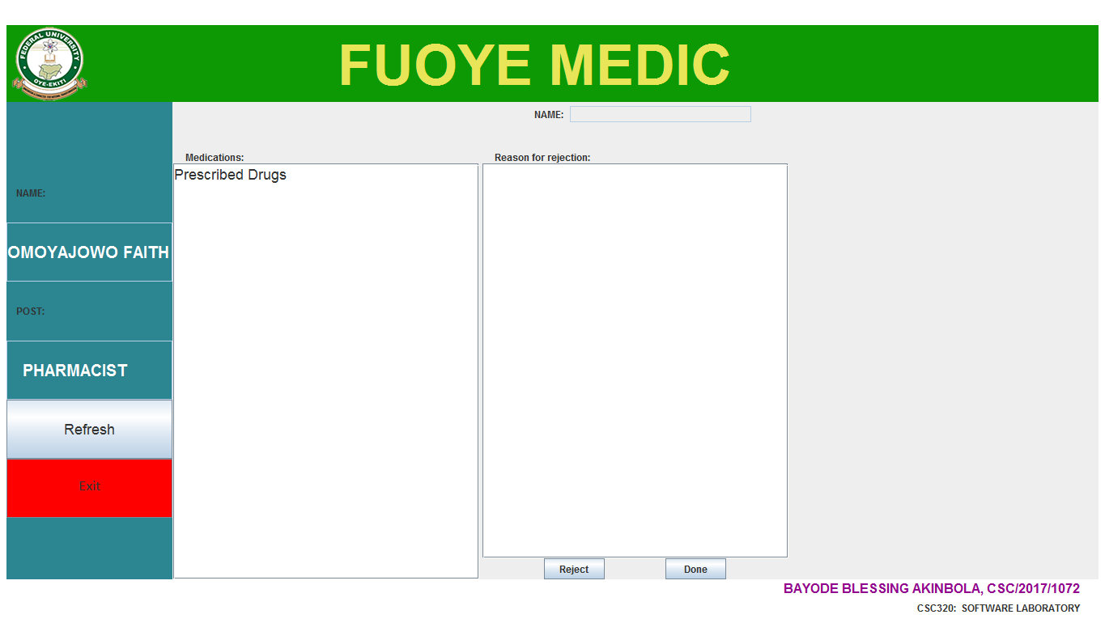

**Medical Record Officer**

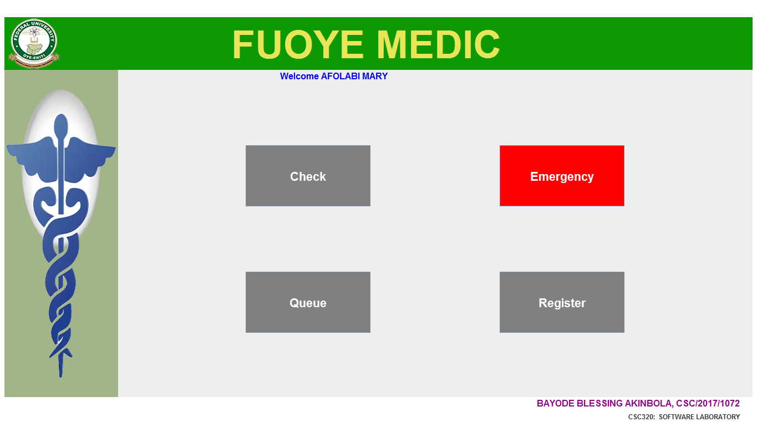

1. **User Guide** 
   1. **Medical Record Officer**
2. Lauch the application **FUOYE MEDIC**.
3. At the display of the login page, enter your **login credentials**.
4. Click on the **Check** button at the visit of each Patients, verify their details to proceed on the vital test capturing.
5. From the home page, click on the **Emergency** button to perform an emergency search.
6. To view the available Patients and their present stage, click on the **Queue** button.
7. To open a new Medical Record for a new Patient, click on the **Registration** button.
   1. **Doctor**
8. Lauch the application **FUOYE MEDIC**.
9. At the display of the login page, enter your **login credentials**.
10. **Refresh** the page to view available Patient(s).
11. Click on the **Ready** button to attend to the patient selected.
    1. **Laboratory Attendant**
12. Lauch the application **FUOYE MEDIC**.
13. At the display of the login page, enter your **login credentials**.
14. **Refresh** the page to view available Patient(s).
15. Click on the **Ready** button to attend to the patient selected.
    1. **Pharmacist**
16. Lauch the application **FUOYE MEDIC**.
17. At the display of the login page, enter your **login credentials**.
18. **Refresh** the page to view available Patient(s).
19. Click on the **Ready** button to attend to the patient selected.
20. **References**
    1. Jennifer Prah Ruger and Dereck Yach. The Global Role of the World Health Organisation.

[www.ndoi.nlm.nih.gov/pmc/article/PMC3981564/](http://www.ndoi.nlm.nih.gov/pmc/article/PMC3981564/)

* 1. Mandl, K.D. Public standards and patients’ control: how to keep medical Records (2001).

<https://doi.org/io.1136/bmj.322.7281.283>

* 1. stroetmann, K.A., Artmann, J., Stroetmann. European countries on their journey towards National e-health inrastructures. (2011).